Dr Jekyll in Dr Jekyll and Mr Hyde
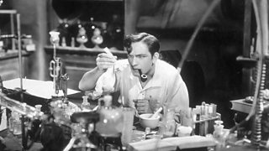
At the beginning of the novel Dr Jekyll is shown to be:
- respectable
- wealthy
- intelligent

Dr Jekyll is a well-respected and intelligent scientist. He is a wealthy man and lives in a house with his butler, Poole. To the rear of his house, with a separate entrance onto a side street, he has his own laboratory. It is here that he is conducting his most ambitious experiment yet - and it is this experiment which causes him to become erratic and alienated from his friends and Victorian society.
As the novel progresses, Jekyll becomes unpredictable and decides to leave all of his belongings and wealth to the scoundrel, Mr Hyde, in his will. This causes his friend Utterson to become very concerned and very anxious to find out more about Mr Hyde.

Mr Hyde in Dr Jekyll and Mr Hyde
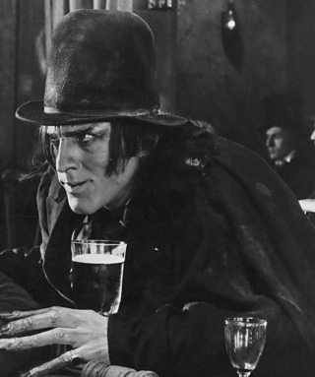
- evil
- murderous
- Jekyll's alter ego
Mr Hyde is described as devilish, evil and a criminal mastermind. Stevenson makes Hyde more mysterious by only hinting at his physical appearance - he is smaller than Jekyll and whenever people see him, they are deeply affected by his looks and spirit.
He is violent and commits terrible crimes - the trampling of an innocent young girl and the murder of Carew. He is unforgiving and doesn't repent for his crimes and sins. He is selfish and wishes for complete dominance over Jekyll.
 | How is Dr Jekyll like this? | Evidence | Analysis
Determined | Dr Jekyll is determined as he wants his experiment to succeed. He is so determined that he risks losing everything in order for him to succeed - his friendships, reputation and wealth. | "I do sincerely take a great, a very great interest in that young man." | The repetition of 'great' emphasises how determined Jekyll is and illustrates how he feels about Mr Hyde. The use of 'sincerely' shows that his determination and passion are real.
Respected | Dr Jekyll is respected due to his wealth, reputation as a charitable man and his discoveries in science. | The doctor gave one of his pleasant dinners to some five or six old cronies, all intelligent reputable men, and all judges of good wine. | This shows that he is well-liked and respected in the society of Victorian London. As all of the men are judges of 'good wine', it indicates to the reader their wealth and respectability.
Intelligent | Dr Jekyll is intelligent due to his innovative experiments which are perceived by some others as worldly and un-godly, particularly by the conventional scientist, Dr Lanyon. | Henry Jekyll, M.D., D.C.L., LL.D., F.RS., etc. | The titles that are attached to Dr Jekyll's name highlight his intelligence, as he has many degrees and qualifications. The use of 'etc.' suggests there are more.
Erratic | Dr Jekyll becomes more erratic as the novel develops. This is because he is trying to conceal Mr Hyde from everyone. He's also trying to control his experiment, but failing. | ...before the smile was struck out of his face and succeeded by an expression of such abject terror and despair, as froze the very blood of the two gentleman below. | This highlights the change in Dr Jekyll's behaviour, as before this quotation, Dr Jekyll was happily talking to Mr Utterson. However, Stevenson describes a sudden change in Dr Jekyll's behaviour. The word 'struck' shows that Hyde's appearance has changed Dr Jekyll's behaviour instantly.

 | How is Mr Hyde like this? | Evidence | Analysis
Ugly | He is described as ugly and Stevenson suggests he has the face of Satan. Everybody Hyde meets in the novel is afflicted with his 'nightmarish' appearance. | "There is something wrong with his appearance; something displeasing, something downright detestable. I never saw a man so disliked." | This quote from Enfield shows that he is greatly appalled and disgusted by Hyde's appearance, suggesting that he is other-worldly and doesn't belong in the reputable society of Victorian London. The repetition of 'something' exaggerates how deformed Hyde is, as Enfield can't quite put his finger on it.
Murderous | Hyde murders Carew and tramples on a little girl causing her legs to break. | ...with ape-like fury, he was trampling his victim under foot, and hailing down a storm of blows. | The use of the simile 'ape-like fury' describes Hyde as an animal capable of rages, not a human. This shows that Hyde doesn't care about his actions and has no control over his fiery, animalistic behaviour.
Powerful | Towards the end of the book, Hyde becomes the dominant side to Dr Jekyll's personality. Each time Dr Jekyll turns into Mr Hyde, Mr Hyde gets stronger and makes it more difficult for Dr Jekyll to turn to his 'original' self. | "It took on this occasion a double dose to recall me to myself; and alas!" | This shows that Mr Hyde is getting stronger, as Dr Jekyll needs to use more drugs to return to his former self. The use of the exclamation mark suggests that this surprises and also scares Jekyll as he is unsure and wary of Hyde's power.

